**Aim**: Demonstrate Data Fragmentation

**Objectives:** To understand concept of data fragmentation.

**Tools Used:** MySQL Workbench

**Concept:**

* Fragmentation in database management systems (DBMS) refers to the division of data and indexes into non-contiguous pieces, influencing how data is stored and retrieved.
* There are two main types of fragmentation: internal and external. Internal fragmentation occurs when allocated space within data structures is not fully utilized, leading to wasted storage.
* External fragmentation happens when free space in the database is scattered throughout, hindering efficient use of available storage.
* Both types can impact system performance, causing delays in data access and retrieval.
* Managing fragmentation is crucial for optimizing database performance, often involving techniques such as defragmentation or rebuilding indexes to ensure efficient storage and retrieval of data

**Problem Statement:**

Demonstrate all syntax with the help on the problem statement given by instructor.

**Solution:**

1. **Create Two users (User1<rollno> and User2<rollno>) using parent login.**

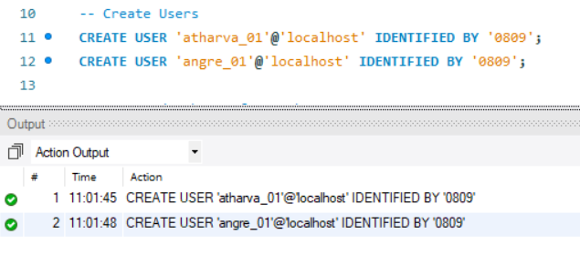

1. **Create a table employee with attributes empid, ename, address, salary, department in parent login.**

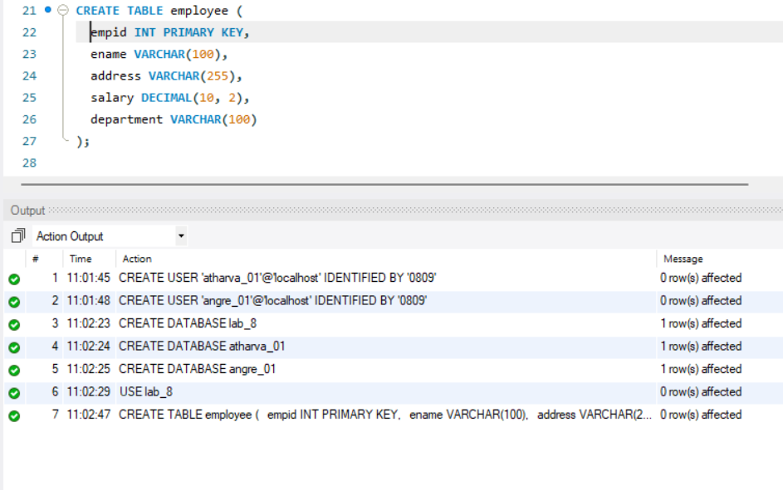

1. **Create link to the previously created users from the parent login.**

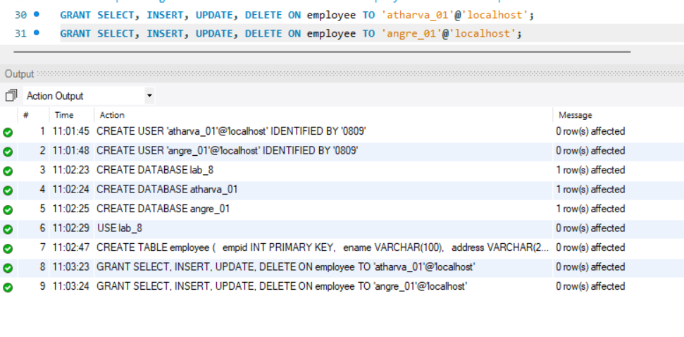

1. **Create table employee with attributes empid, ename, department with user1<rollno> login**

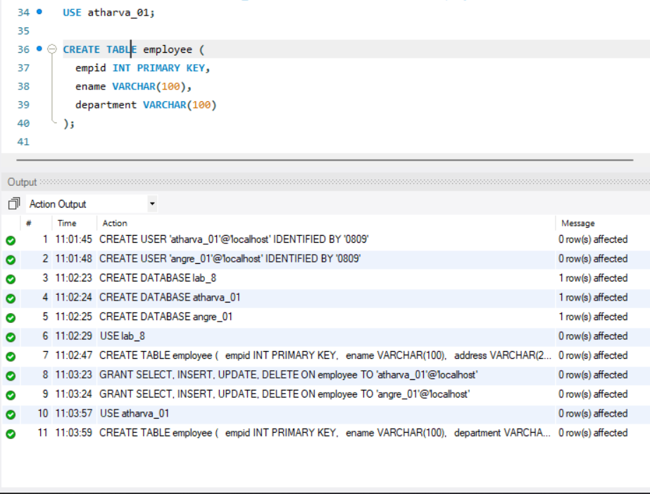

1. **Create table employee with attributes empid, address and salary with user2<rollno>login.**

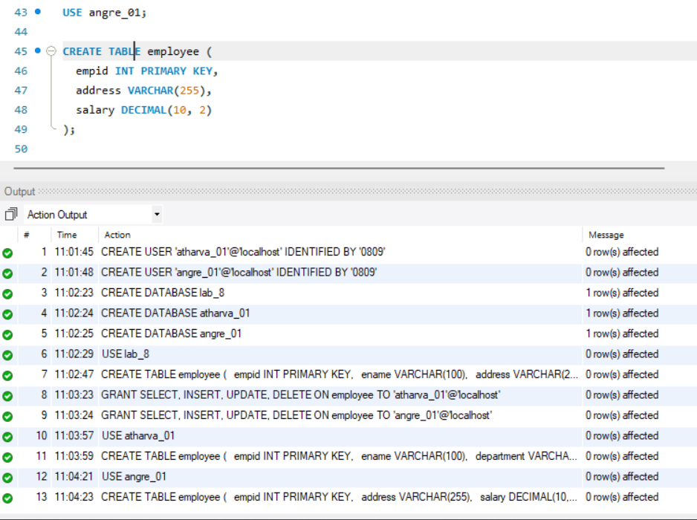

1. **Create trigger for inserting records into fragmented table.**

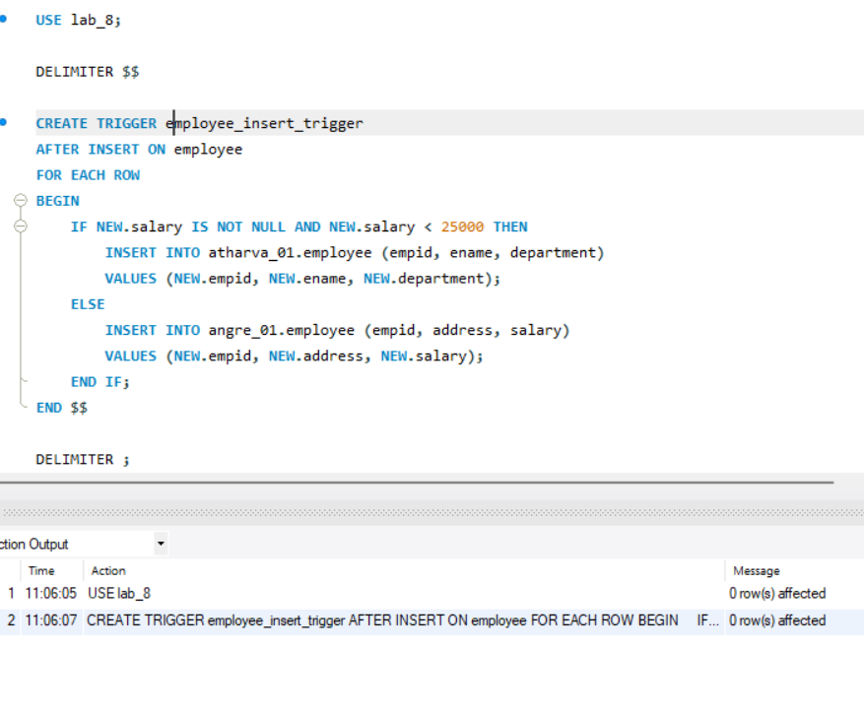

1. **Insert minimum 5 records in employee table created in parent.**

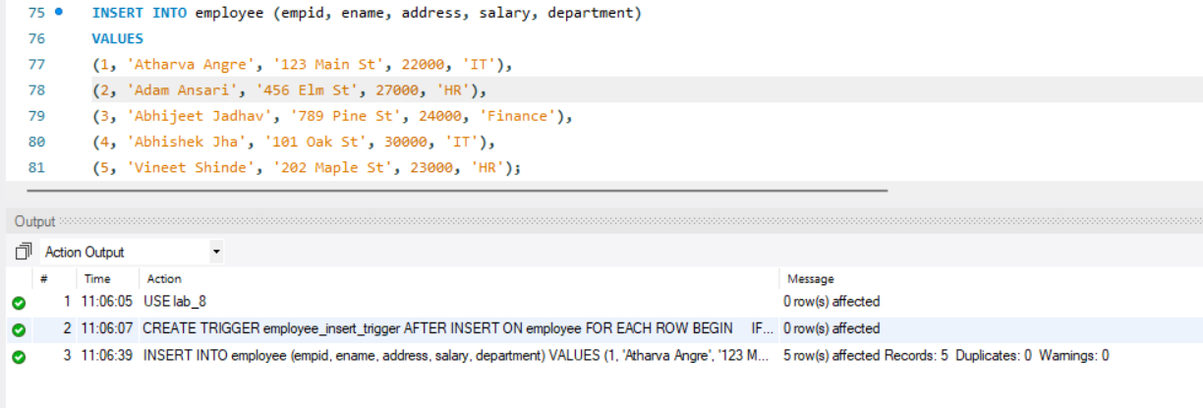

1. **Display records from employee table of user1<rollno> and user2<rollno>.**

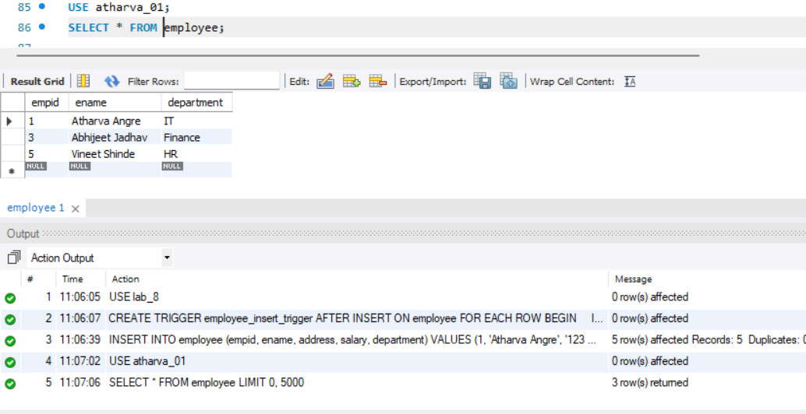

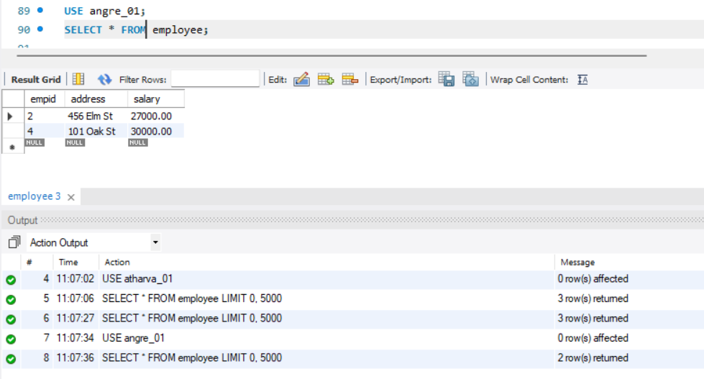

1. **Display employees whose salary is more than 25000**

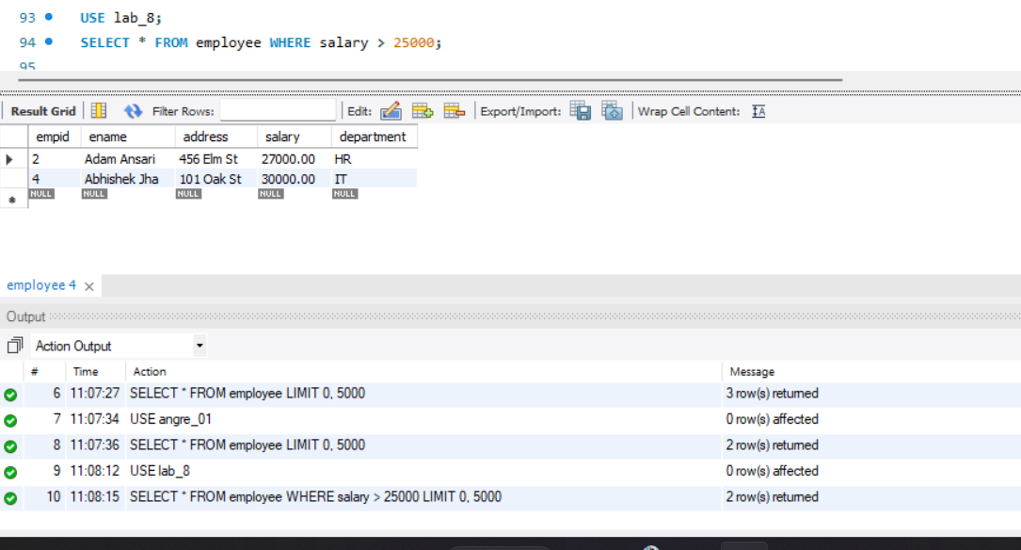

1. **Create table movietab in parent login using attributes movie_title, Language, Length_in_min (LENGTH IN MINUTES), lead_actor, lead_actress.**

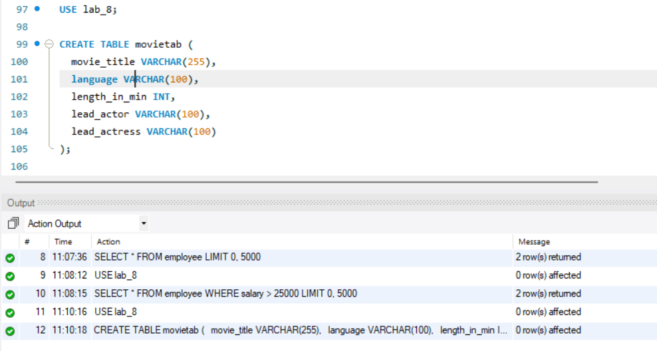

1. **Create link to the users User1<rollno> & User2<rollno> from the parent login.**

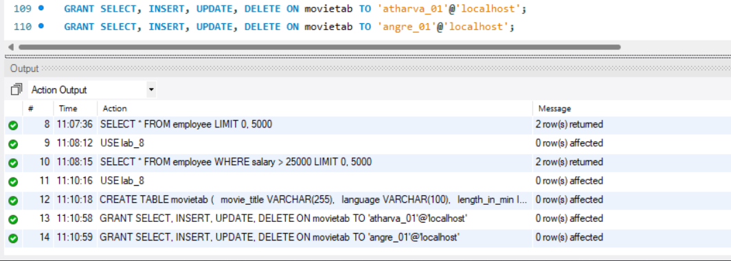

1. **Create table movietab with same attributes in user1<rollno>.**

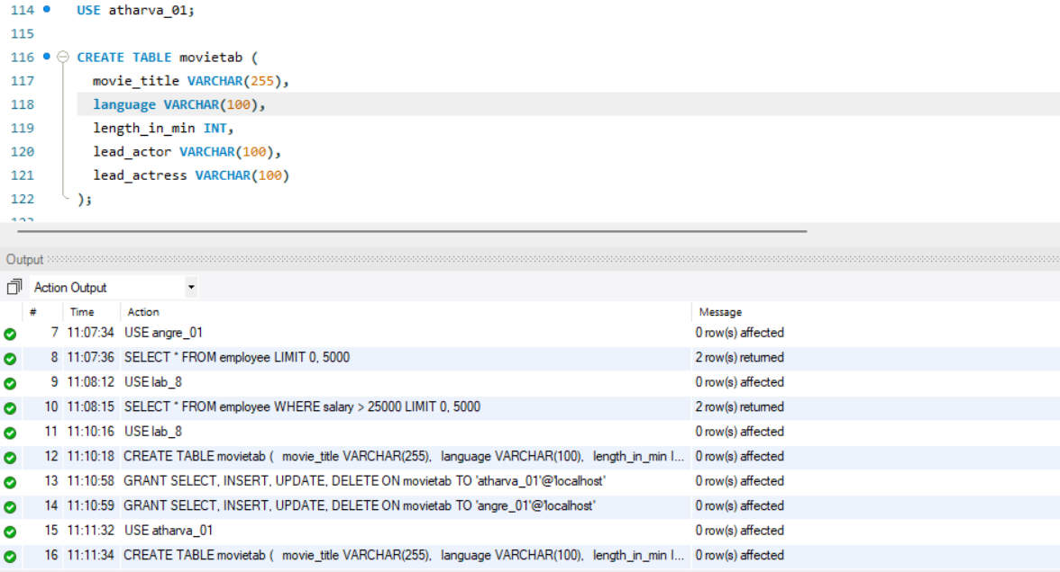

1. **Create table movietab with same attributes in user2<rollno>.**

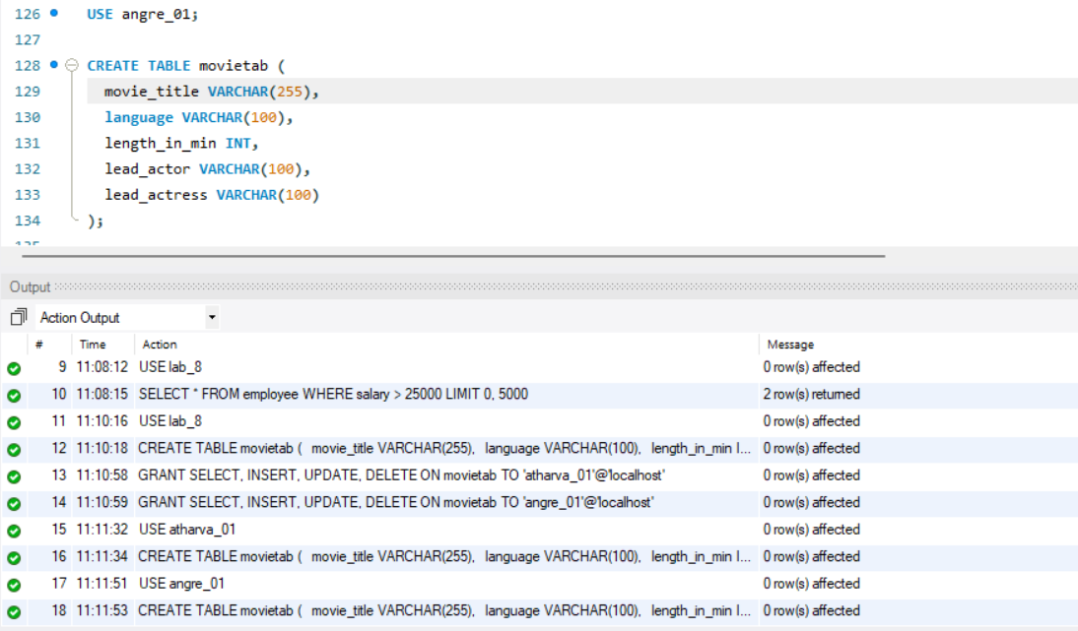

1. **Create trigger in main user to insert data into fragmented table based on Length_in_min. (if Length_in_minare <60 then insert into movietab table of user1<rollno>otherwise inuser2<rollno>movietab table).**

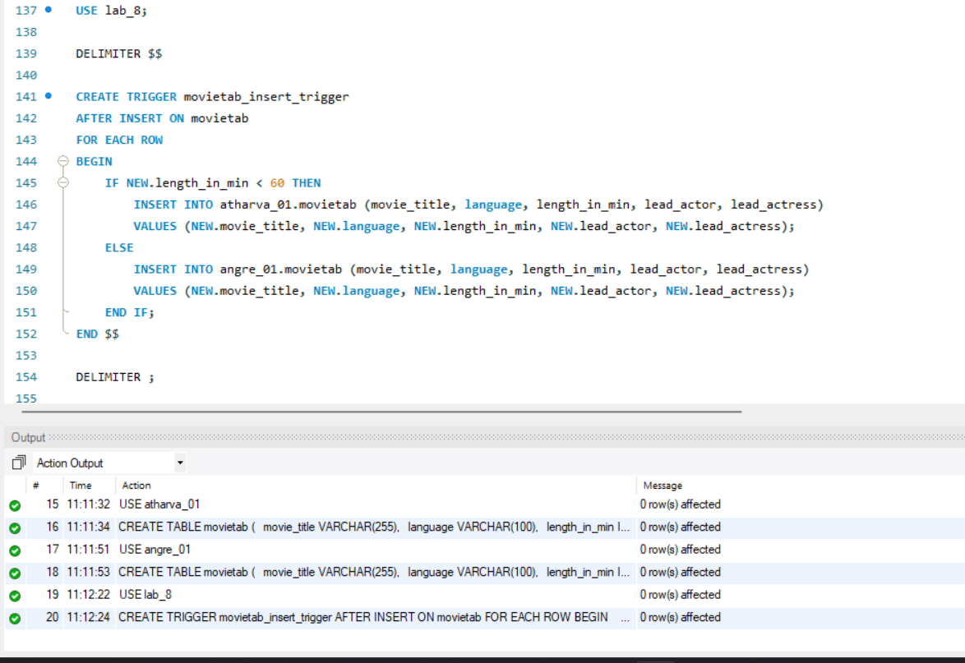

1. **Display data from both the horizontal fragments.**

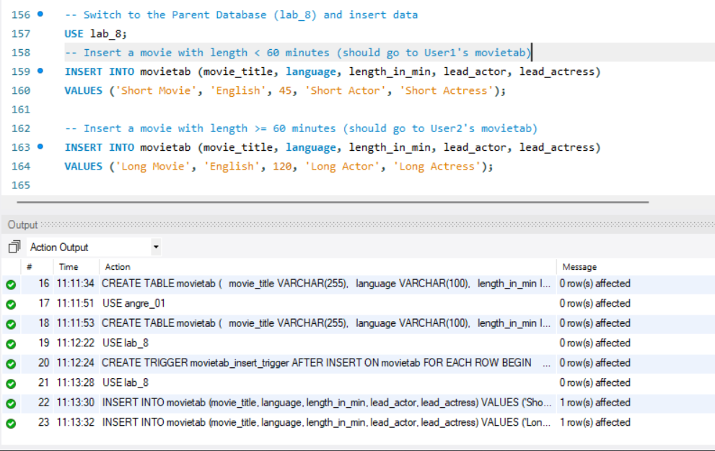

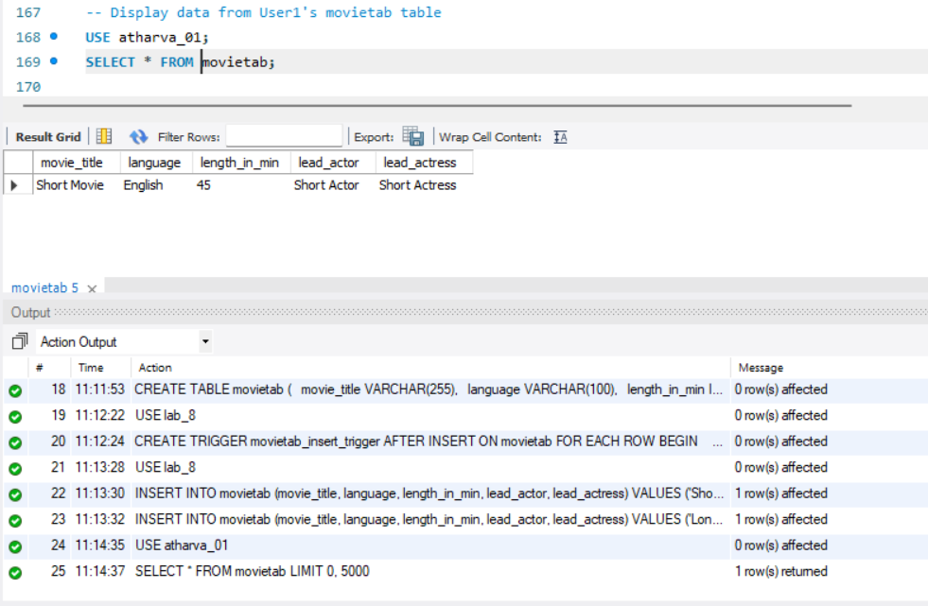

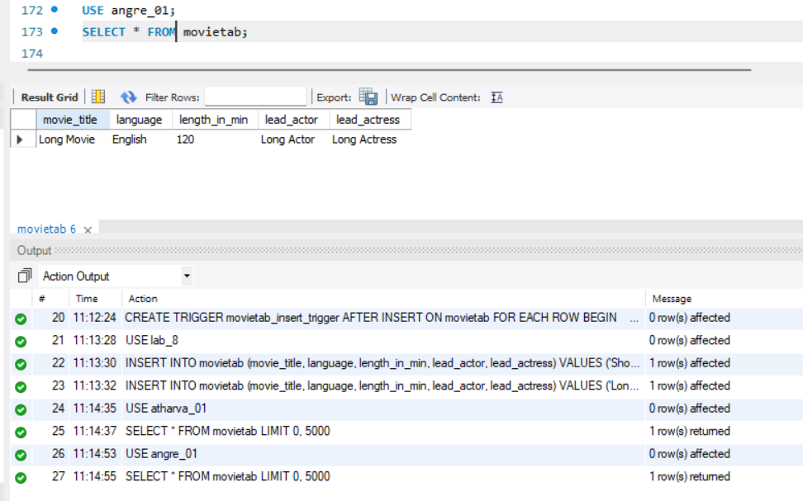

**Observation**:

In MySQL, fragmentation can degrade query performance by increasing disk I/O and inefficient use of storage. Frequent inserts, updates, or deletes can cause data to become scattered across disk storage, leading to slower queries. However, MySQL provides corrective measures such as the OPTIMIZE TABLE command, which reorganizes the table and rebuilds indexes, improving query performance and reclaiming disk space. Proper index management and table optimization help reduce fragmentation, enhancing both disk space efficiency and query speed, making the system more efficient overall.